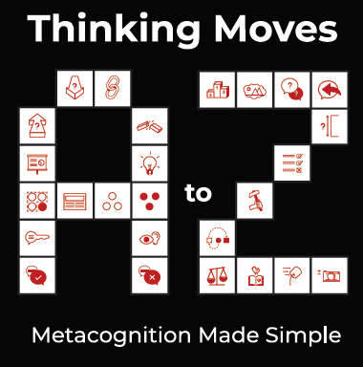

Thinking Moves A – Z
Early Years Synonyms
Taster Pack

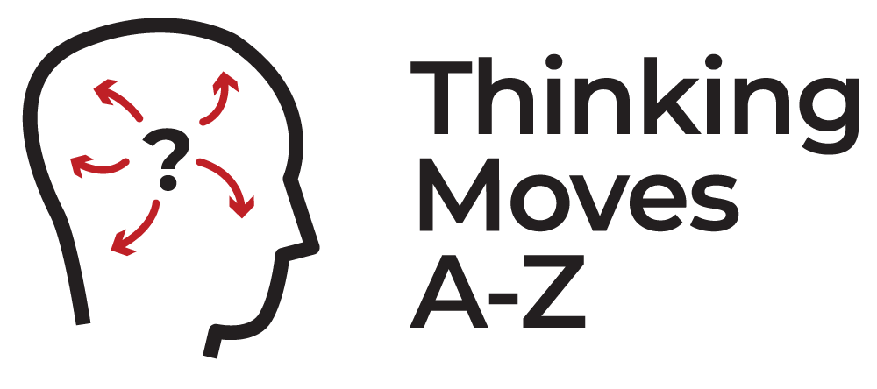

 | THINKING MOVES | EARLY YEARS SYNONYMS
A | AHEAD | LOOK FORWARD
B | BACK | LOOK BACK
C | CONNECT | SAY WHAT’S THE SAME
D | DIVIDE | SAY WHAT’S DIFFERENT
L | LOOK / LISTEN | USE YOUR SENSES
Z | ZOOM | LOOK CLOSELY

